

Capstone Project Report
Report 4 – Software Design Document

– Ho Chi Minh City, December 2025 –

Table of Contents
I. Record of Changes 3
II. Software Design Document 4
1. System Design 4
1.1 System Architecture Diagram 4
1.2 Component Diagram 5
2. Database Design 7
3. Detailed Design 15
3.1 Program & Course Management 15
3.1.1 Class Diagram 15
3.1.2 Sequence Diagram - Admin Creates Program 15
3.1.3 Sequence Diagram - Admin Creates Course 17
3.1.4 Sequence Diagram - Admin Adds Course To Program 18
3.2 Class Management & Enrollment 19
3.2.1 Class Diagram 19
3.2.2 Sequence Diagram - Trainee Enrolls to Class 19
3.2.3 Sequence Diagram - Admin Confirms Enrollment 21
3.3 Simulation Practice Management 22
3.3.1 Class Diagram 22
3.3.2 Sequence Diagram - Simulation Manager Creates Practice 22
3.3.3 Sequence Diagram - Trainees Attempt Practice 24
3.4 Final Exam Management 25
3.4.1 Class Diagram 25
3.4.2 Sequence Diagram - Instructor Configs Final Exam 25
3.5 Dashboard & Reports 27
3.5.1 Class Diagram 27
3.5.2 Sequence Diagram - Admin Views Dashboard 27

I. Record of Changes
Date | A*  M, D | In charge | Change Description
28/10/2025 | A | Duong Minh Nhat | Adding document
10/11/2025 | M | Duong Minh Nhat | Updating document
01/12/2025 | M | Duong Minh Nhat | Reviewing and updating document
*A - Added M - Modified D - Deleted

II. Software Design Document

1. System Design

1.1 System Architecture Diagram
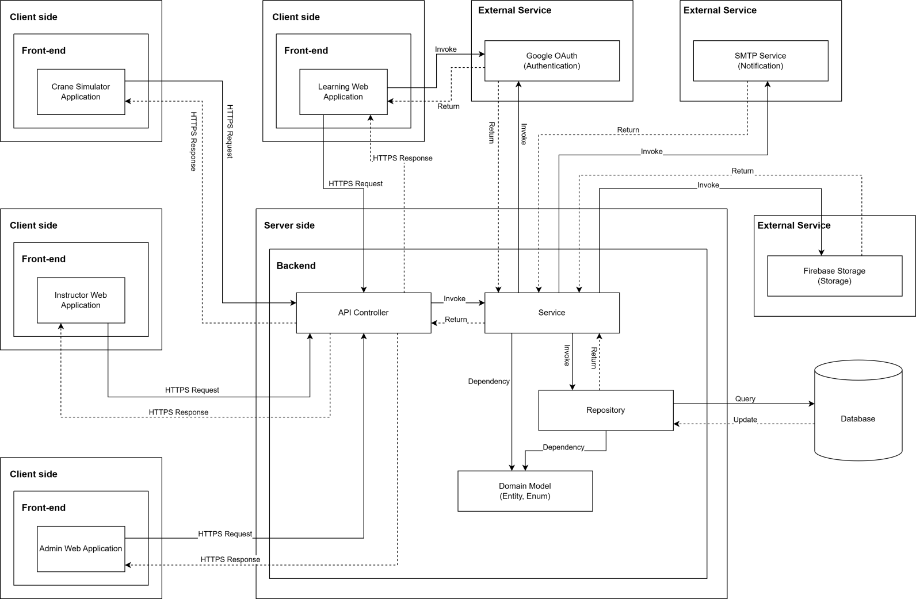

System Architecture Diagram Descriptions
No | Name | Description
1 | Crane Simulator Application | Desktop application for practical crane operation training, communicates with backend via HTTPS to access training content and submit practice results
2 | Learning Web Application | Web-based application for trainees to access learning materials, complete courses, take quizzes, and track their learning progress
3 | Instructor Web Application | Web application for instructors to manage classes, create and grade quizzes, provide feedback, and monitor student progress
4 | Admin Web Application | Web application for administrators to manage users, programs, courses, system settings, and overall platform administration
5 | API Controller | RESTful API layer that receives HTTPS requests from client applications, routes them to appropriate services, and returns responses
6 | Service | Business logic layer containing core application logic, processing business rules, orchestrating workflows, and coordinating between controllers and repositories
7 | Repository | Data access layer that abstracts database operations, handles CRUD operations, and manages data persistence using Entity Framework or similar ORM
8 | Domain Model (Entity, Enum) | Domain entities and enumerations representing the core business objects and data structures (Users, Courses, Classes, Quizzes, etc.)
9 | Database | SQL Server database storing all system data including users, courses, enrollments, quiz attempts, practice results, and certificates
10 | Google OAuth (Authentication) | External authentication service for user login using Google accounts, providing secure OAuth 2.0 authentication flow
11 | SMTP Service (Notification) | External email service for sending notifications, alerts, password resets, and course-related communications to users
12 | Firebase Storage (Storage) | Cloud storage service for storing and serving media files including course materials, videos, images, documents, and user-uploaded content

1.2 Component Diagram

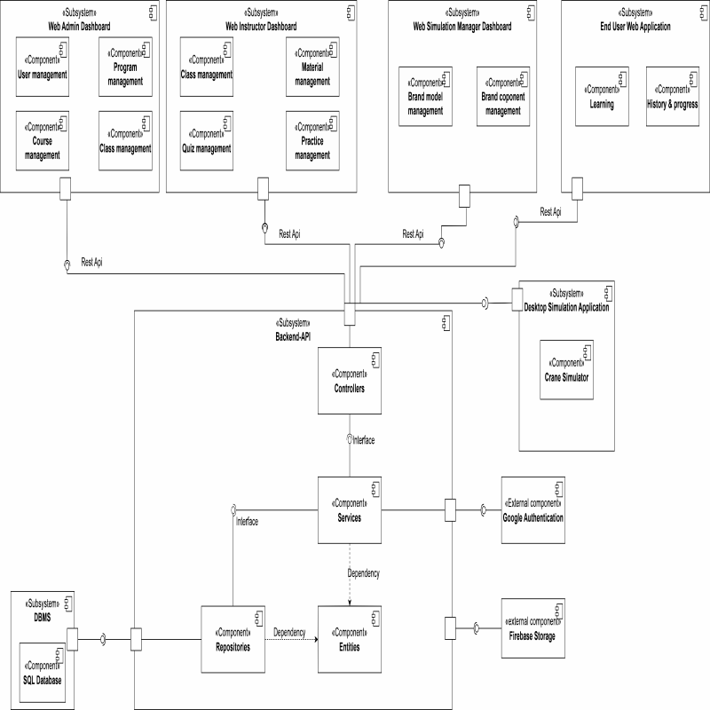

Component Diagram Descriptions
No | Name | Description
1 | Web Admin Dashboard | Web administrative interface for Admin, including user management, program management, and course management features
2 | User management | Component for managing users, handling account information, permissions, and user administration in the system
3 | Program management | Component for managing training programs, organizing courses and curriculum
4 | Course management | Component for managing courses, learning content, lectures, and materials
5 | Web Instructor Dashboard | Web interface for instructors, including class management and quiz management
6 | Class management | Component for managing classes, student lists, schedules, and attendance
7 | Material management | Component for managing learning materials, lectures, videos, and attached files
8 | Quiz management | Component for managing quizzes, questions, answers, and test results
9 | Practice management | Component for managing practice exercises, assignments, and homework
10 | Web Simulation Manager Dashboard | Simulation management interface, including brand model management and brand component management
11 | Brand model management | Component for managing brand models in business simulation
12 | Brand component management | Component for managing components and competitors in simulation
13 | End User Web Application | Web application for end users (students), including learning features and history & progress tracking
14 | Learning | Component handling the learning process, viewing lectures, and completing exercises for students
15 | History & progress | Component tracking learning history and course completion progress for students
16 | End User Desktop Application | Desktop application for end users, including practical training features
17 | Practical Training | Component handling practical exercises on desktop application
18 | Firebase Storage | Firebase file storage service for storing images, videos, documents, and attached files
19 | Backend API | Backend API system handling business logic, including Controllers, Services, Repositories, and Entities
20 | Controllers | Controller layer handling HTTP requests from clients, routing to corresponding services
21 | Services | Business logic layer containing business rules and system processing logic
22 | Repositories | Data access layer handling CRUD operations with the database
23 | Entities | Layer defining data objects (data models) mapped to the database
24 | Google Authentication | Component authenticating users through Google OAuth, supporting Google account login
25 | DBMS | Database management system containing SQL Database storing all system data
26 | SQL Database | SQL database (PostgreSQL/MySQL) storing user data, courses, exercises, and learning results

Database Design

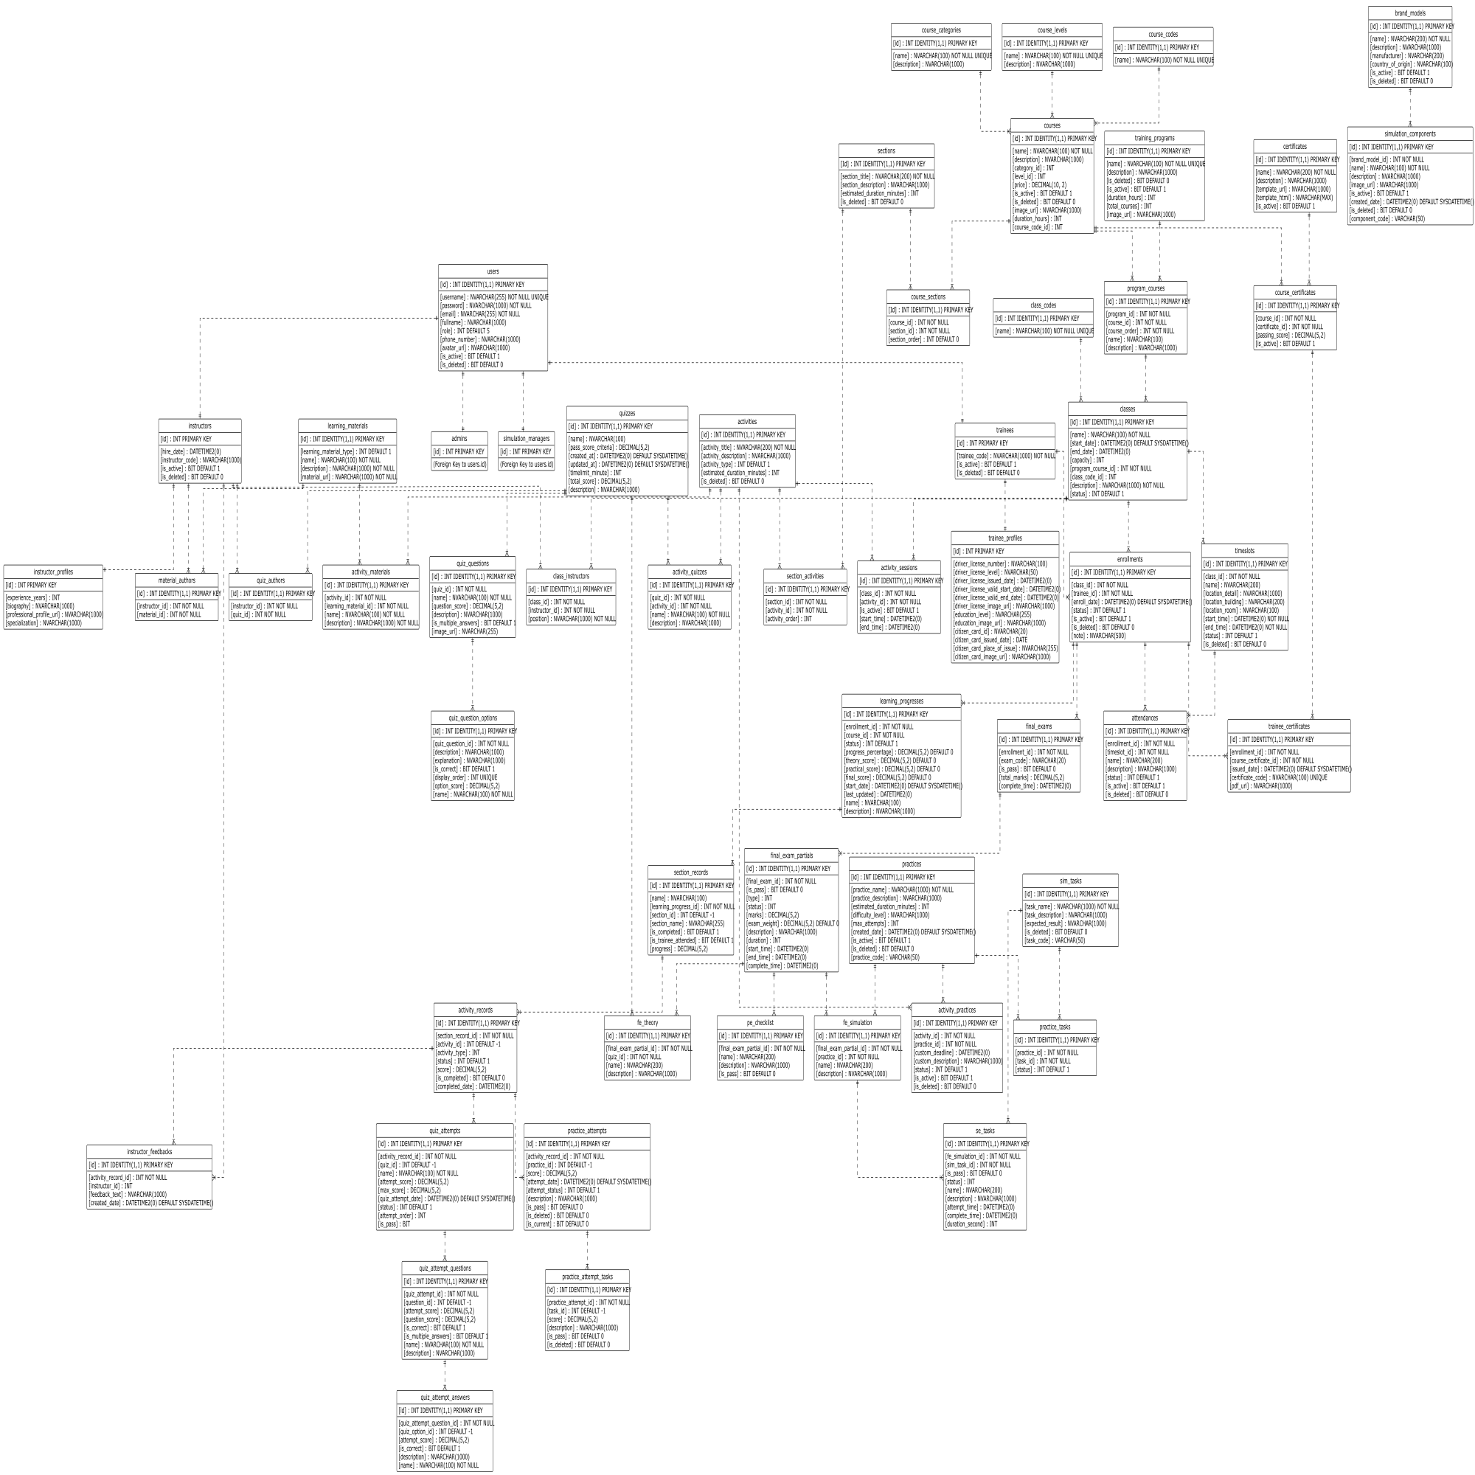

Table Descriptions
No | Table | Description
1 | users | Stores the core account information for all system users including login credentials and contact info.  - Primary keys: id  - Foreign keys: None
2 | admins | Stores specific information for users with the Admin role, linked to the main user record.  - Primary keys: id  - Foreign keys: id
3 | simulation_managers | Stores specific information for Simulation Managers, linked to the main user record.  - Primary keys: id  - Foreign keys: id
4 | instructors | Stores specific information for Instructors, including employment details.  - Primary keys: id  - Foreign keys: id
5 | trainees | Stores specific information for Trainees/Learners.  - Primary keys: id  - Foreign keys: id
6 | instructor_profiles | Contains detailed profile information for instructors such as experience and biography.  - Primary keys: id  - Foreign keys: id
7 | trainee_profiles | Contains detailed profile information for trainees, including driver license and citizen card details.  - Primary keys: id  - Foreign keys: id
8 | course_categories | Lookup table for defining different categories of courses.  - Primary keys: id  - Foreign keys: None
9 | course_levels | Lookup table for defining the difficulty or progression levels of courses.  - Primary keys: id  - Foreign keys: None
10 | course_codes | Lookup table for standardized course codes. - Primary keys: id - Foreign keys: None
11 | courses | Stores the main course definitions including metadata like price and duration. - Primary keys: id  - Foreign keys: category_id, level_id, course_code_id
12 | training_programs | Defines high-level training programs that aggregate multiple courses.  - Primary keys: id  - Foreign keys: None
13 | program_courses | Junction table linking Courses to Training Programs, defining the order of courses within a program.  - Primary keys: id  - Foreign keys: program_id, course_id
14 | sections | Defines content sections that organize activities within a course.  - Primary keys: Id  - Foreign keys: None
15 | course_sections | Junction table mapping sections to courses and defining their sequence.  - Primary keys: Id  - Foreign keys: course_id, section_id
16 | activities | Stores individual learning activities (e.g., lessons, quizzes) that belong to sections. - Primary keys: id - Foreign keys: None
17 | learning_materials | Stores information about study materials like documents or videos.  - Primary keys: id  - Foreign keys: None
18 | material_authors | Links learning materials to the instructors who authored them.  - Primary keys: id  - Foreign keys: instructor_id, material_id
19 | section_activities | Junction table mapping activities to specific sections and defining their order.  - Primary keys: id - Foreign keys: section_id, activity_id
20 | activity_materials | Links learning materials to specific activities.  - Primary keys: id  - Foreign keys: activity_id, learning_material_id
21 | quizzes | Defines quiz assessments including time limits and passing criteria.  - Primary keys: id  - Foreign keys: None
22 | quiz_authors | Links quizzes to the instructors who created them.  - Primary keys: id  - Foreign keys: instructor_id, quiz_id
23 | quiz_questions | Stores questions belonging to a specific quiz.  - Primary keys: id  - Foreign keys: quiz_id
24 | quiz_question_options | Stores the possible answer options for a quiz question.  - Primary keys: id  - Foreign keys: quiz_question_id
25 | activity_quizzes | Junction table linking a Quiz to an Activity entity.  - Primary keys: id  - Foreign keys: quiz_id, activity_id
26 | practices | Defines practical training exercises or simulation scenarios.  - Primary keys: id  - Foreign keys: None
27 | sim_tasks | Defines specific tasks or steps required within a simulation.  - Primary keys: id  - Foreign keys: None
28 | practice_tasks | Junction table linking simulation tasks to a practice scenario.  - Primary keys: id  - Foreign keys: practice_id, task_id
29 | activity_practices | Junction table linking a Practice to an Activity entity.  - Primary keys: id  - Foreign keys: activity_id, practice_id
30 | brand_models | Specific brand models of equipment (cranes) used in simulations.  - Primary keys: id  - Foreign keys: None
31 | simulation_components | Stores detailed components associated with specific brand models.  - Primary keys: id  - Foreign keys: brand_model_id
32 | class_codes | Lookup table for standardized class codes.  - Primary keys: id  - Foreign keys: None
33 | classes | Represents a scheduled instance of a course (program course) with start/end dates.  - Primary keys: id  - Foreign keys: program_course_id, class_code_id
34 | class_instructors | Assigns instructors to specific classes with a designated position.  - Primary keys: id  - Foreign keys: class_id, instructor_id
35 | enrollments | Records the registration of a trainee in a specific class.  - Primary keys: id  - Foreign keys: class_id, trainee_id
36 | timeslots | Defines specific scheduling slots (date/time/location) for a class.  - Primary keys: id  - Foreign keys: class_id
37 | attendances | Tracks trainee attendance for specific timeslots.  - Primary keys: id  - Foreign keys: enrollment_id, timeslot_id
38 | activity_sessions | Schedules specific activities within a class timeframe.  - Primary keys: id  - Foreign keys: class_id, activity_id
39 | final_exams | Stores the overall record of a final exam for an enrollment.  - Primary keys: id  - Foreign keys: enrollment_id
40 | final_exam_partials | Stores specific parts (theory/practical) of a final exam.  - Primary keys: id  - Foreign keys: final_exam_id
41 | pe_checklist | Stores checklist items for grading practical final exams.  - Primary keys: id  - Foreign keys: final_exam_partial_id
42 | fe_theory | Links a final exam partial to a specific theory quiz.  - Primary keys: id  - Foreign keys: final_exam_partial_id, quiz_id
43 | fe_simulation | Links a final exam partial to a specific simulation practice.  - Primary keys: id  - Foreign keys: final_exam_partial_id, practice_id
44 | se_tasks | Tracks the result of specific tasks within a simulation final exam.  - Primary keys: id  - Foreign keys: fe_simulation_id, sim_task_id
45 | certificates | Defines certificate templates available in the system.  - Primary keys: id  - Foreign keys: None
46 | course_certificates | Links certificates to courses, defining passing requirements.  - Primary keys: id  - Foreign keys: course_id, certificate_id
47 | trainee_certificates | Records certificates issued to trainees upon course completion.  - Primary keys: id  - Foreign keys: enrollment_id, course_certificate_id
48 | learning_progresses | Tracks the overall progress of a trainee within an enrollment.  - Primary keys: id  - Foreign keys: enrollment_id
49 | section_records | Tracks a trainee's completion status for specific course sections.  - Primary keys: id  - Foreign keys: learning_progress_id
50 | activity_records | Tracks the detailed status and score of a trainee for specific activities.  - Primary keys: id  - Foreign keys: section_record_id
51 | instructor_feedbacks | Stores feedback provided by instructors on specific activity records.  - Primary keys: id  - Foreign keys: activity_record_id, instructor_id
52 | practice_attempts | Records a specific attempt by a trainee to complete a practice activity.  - Primary keys: id  - Foreign keys: activity_record_id
53 | practice_attempt_tasks | Records the result of individual tasks within a practice attempt.  - Primary keys: id  - Foreign keys: practice_attempt_id
54 | quiz_attempts | Records a specific attempt by a trainee to complete a quiz.  - Primary keys: id  - Foreign keys: activity_record_id
55 | quiz_attempt_questions | Records the trainee's answer/score for a specific question in a quiz attempt.  - Primary keys: id  - Foreign keys: quiz_attempt_id
56 | quiz_attempt_answers | Records the specific option selected by a trainee for a question.  - Primary keys: id  - Foreign keys: quiz_attempt_question_id

3. Detailed Design

3.1 Program & Course Management

3.1.1 Class Diagram
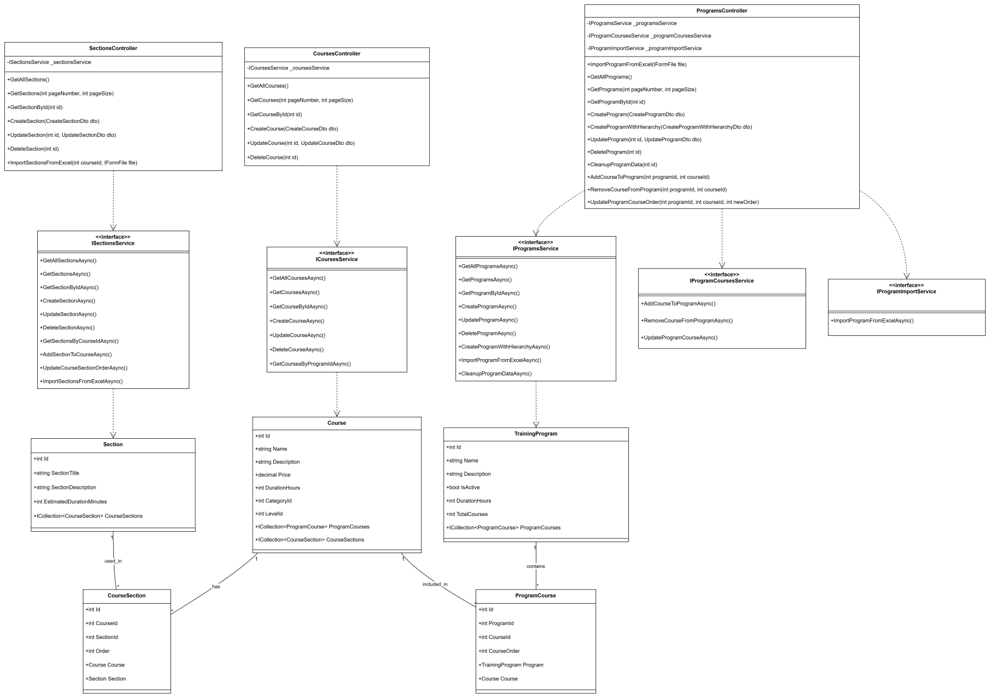

3.1.2 Sequence Diagram - Admin Creates Program

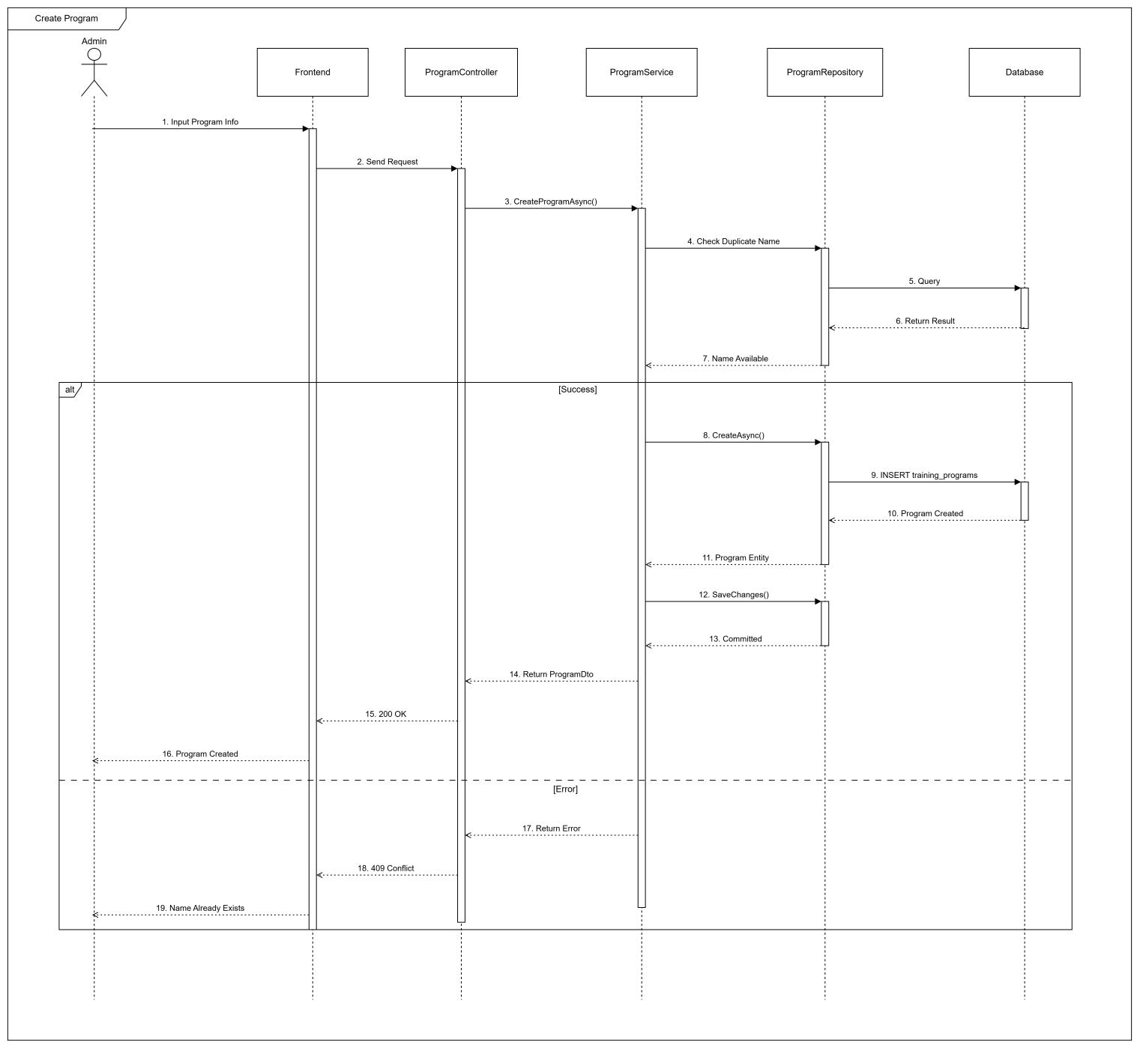

3.1.3 Sequence Diagram - Admin Creates Course
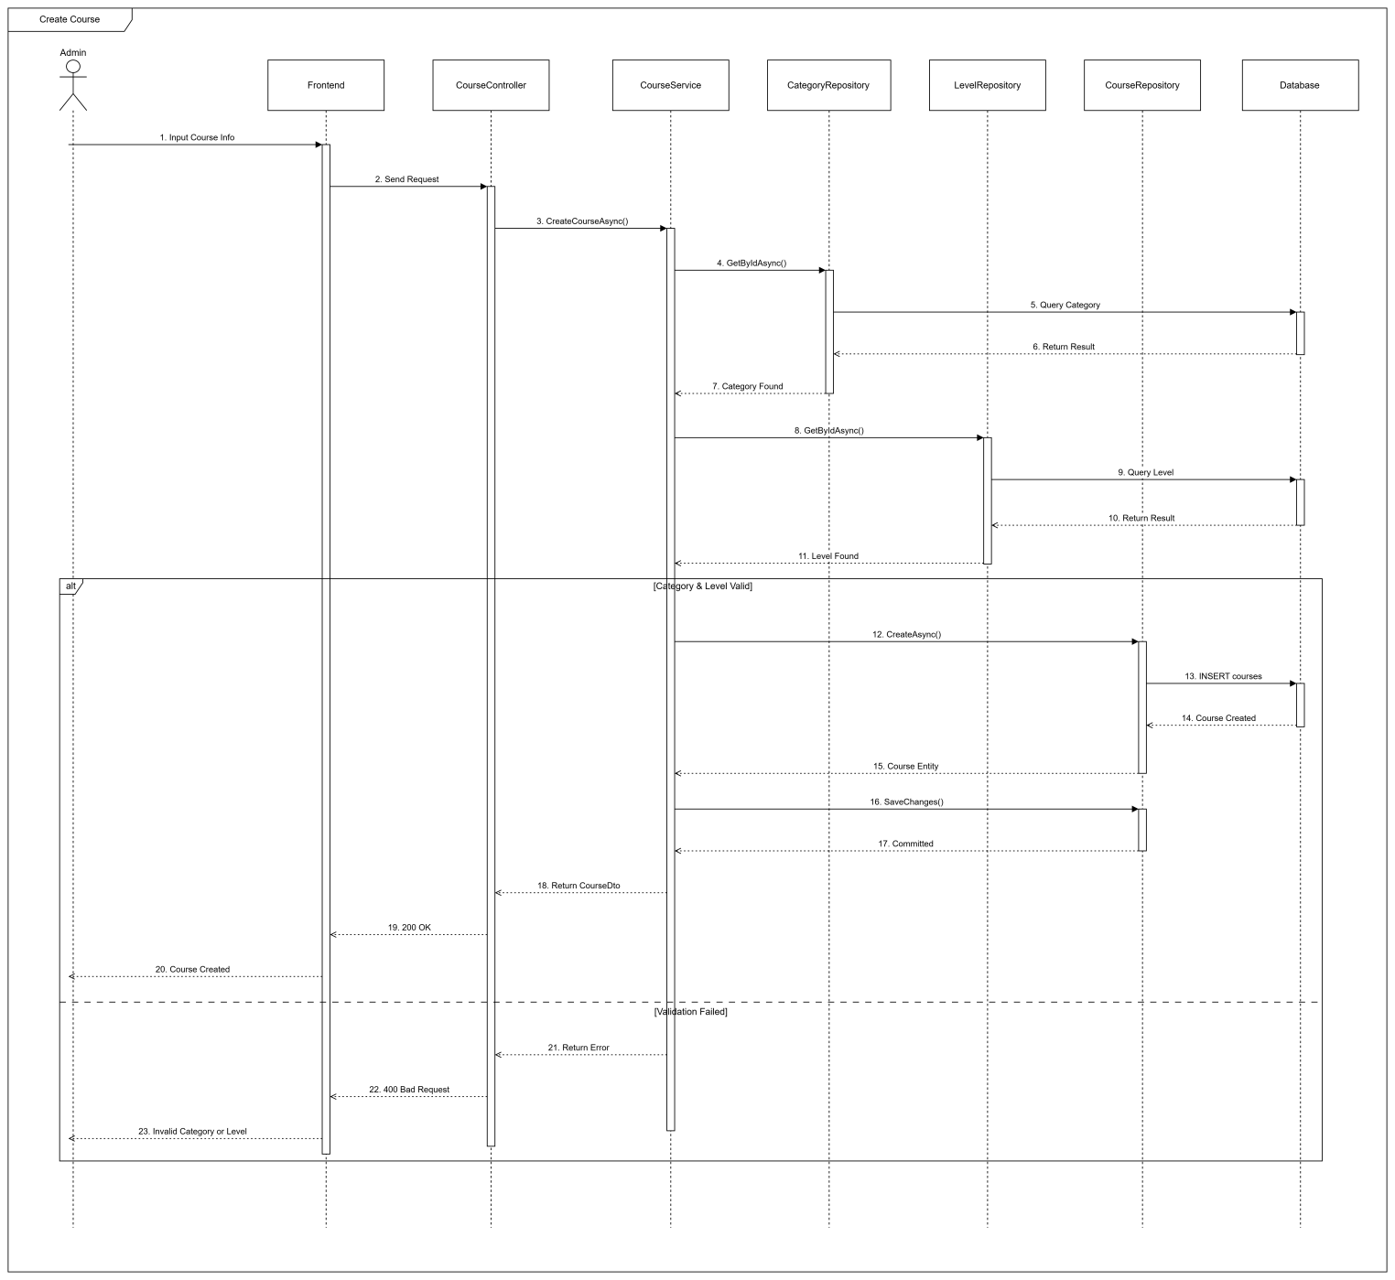

3.1.4 Sequence Diagram - Admin Adds Course To Program
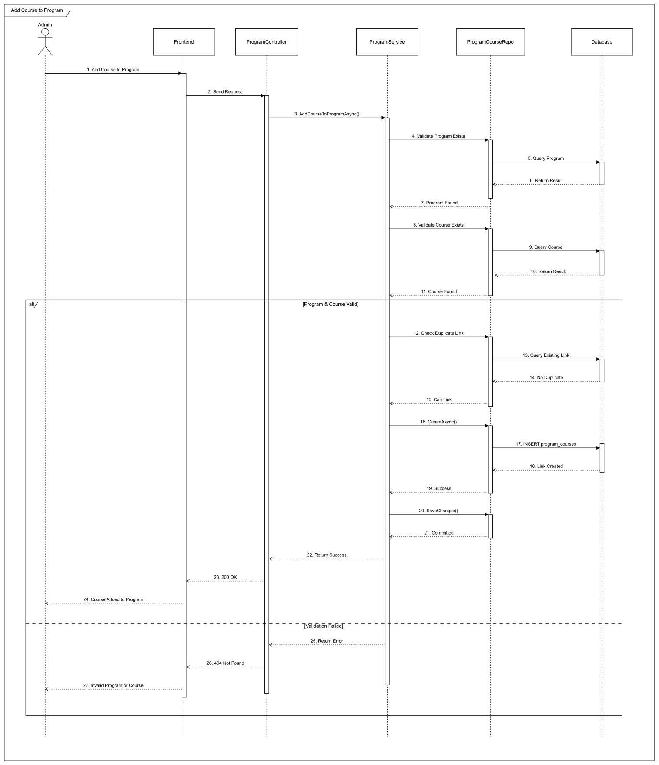

3.2 Class Management & Enrollment

3.2.1 Class Diagram
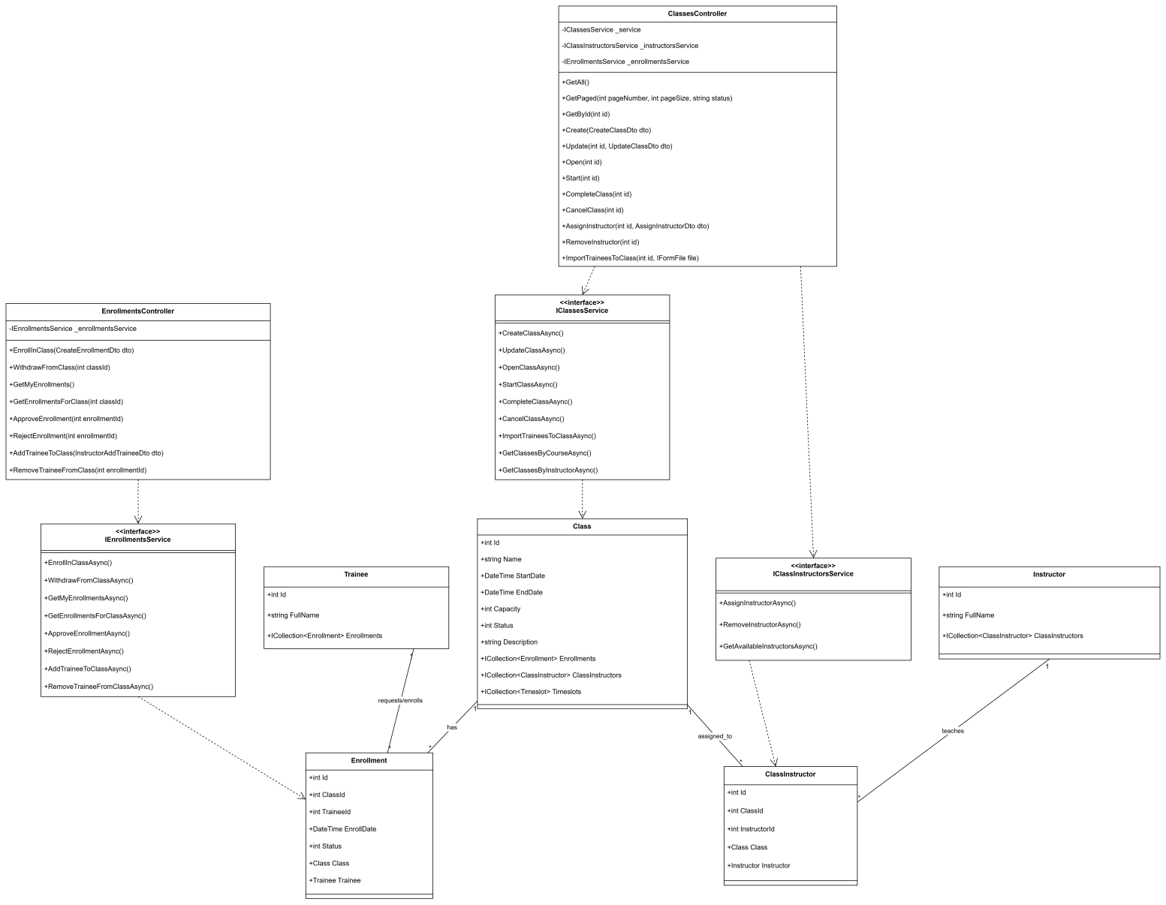

3.2.2 Sequence Diagram - Trainee Enrolls to Class
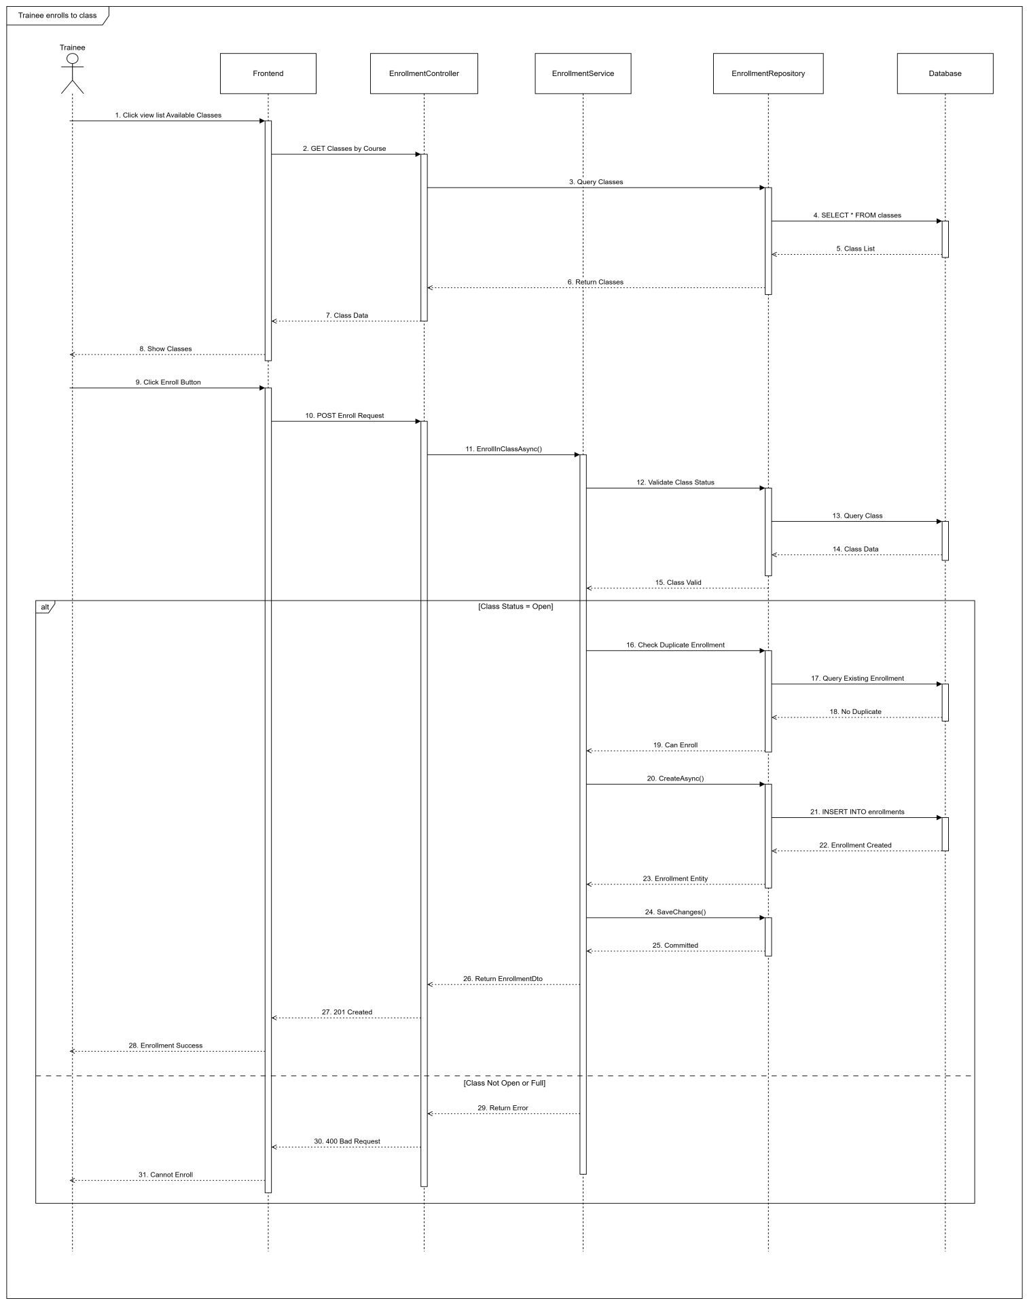

3.2.3 Sequence Diagram - Admin Confirms Enrollment
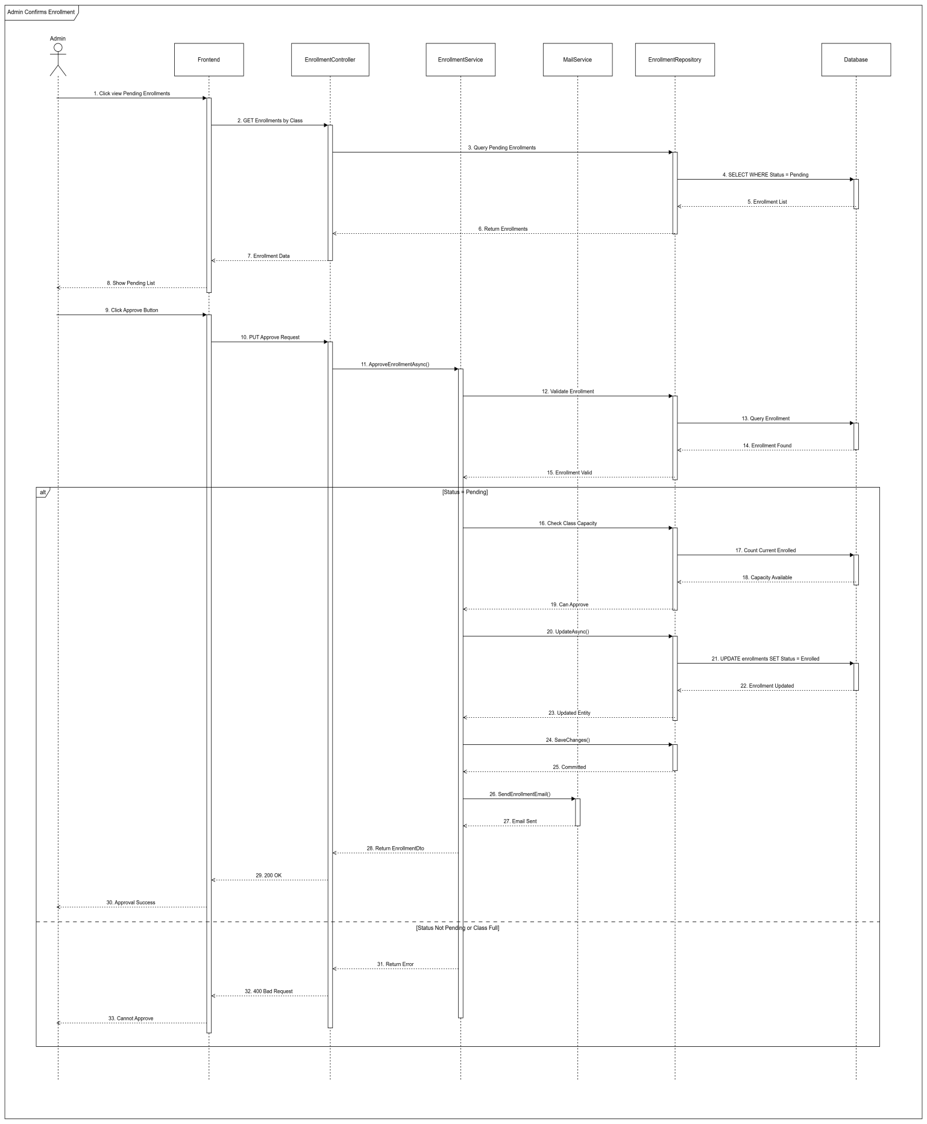

3.3 Simulation Practice Management

3.3.1 Class Diagram
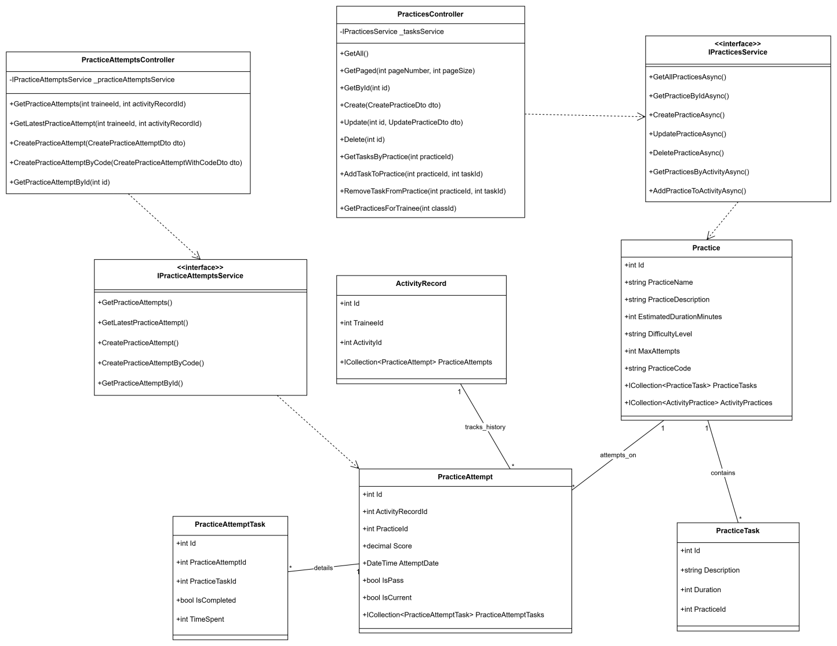

3.3.2 Sequence Diagram - Simulation Manager Creates Practice
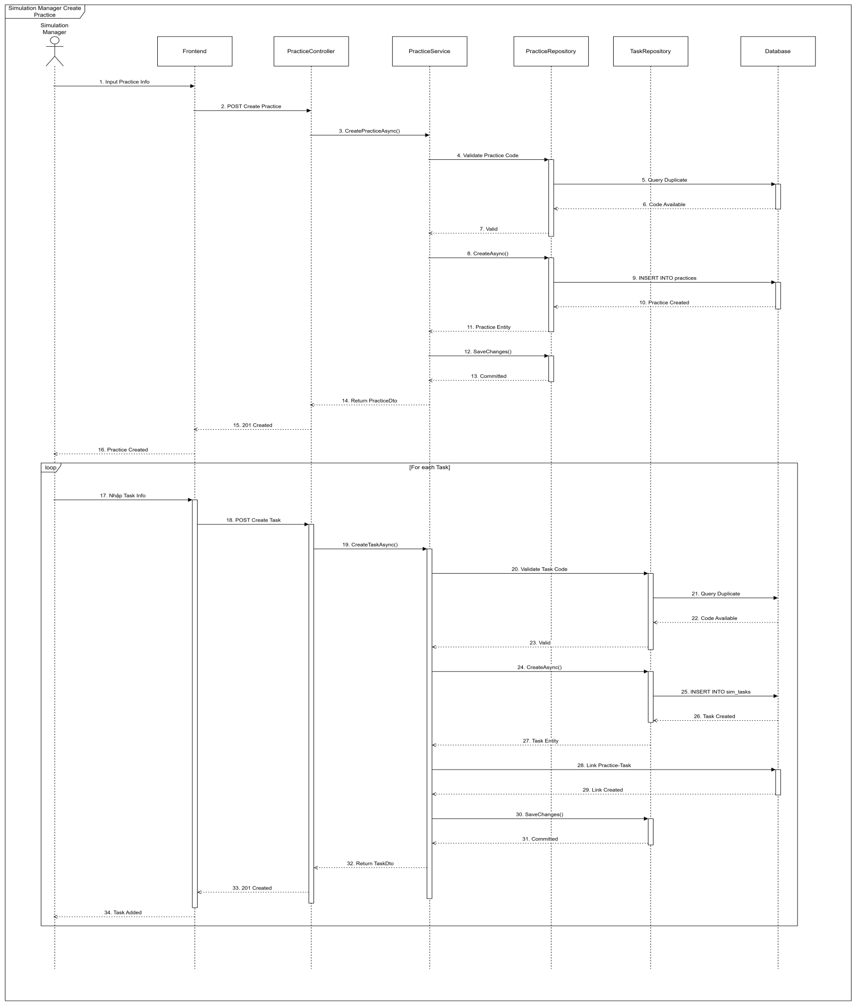

3.3.3 Sequence Diagram - Trainees Attempt Practice
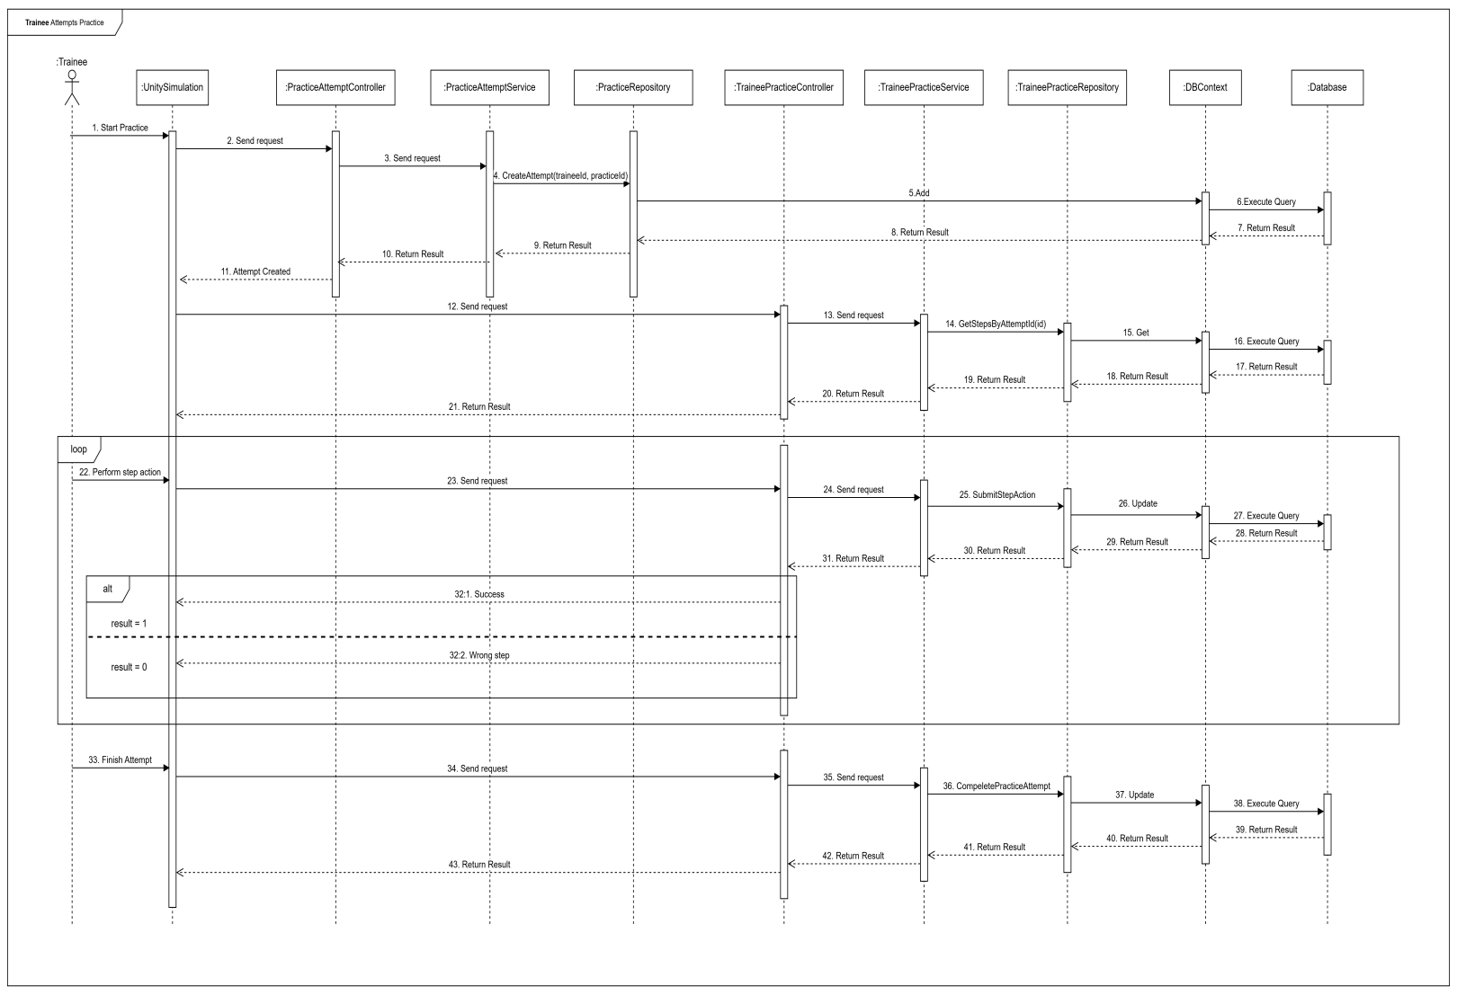

3.4 Final Exam Management

3.4.1 Class Diagram
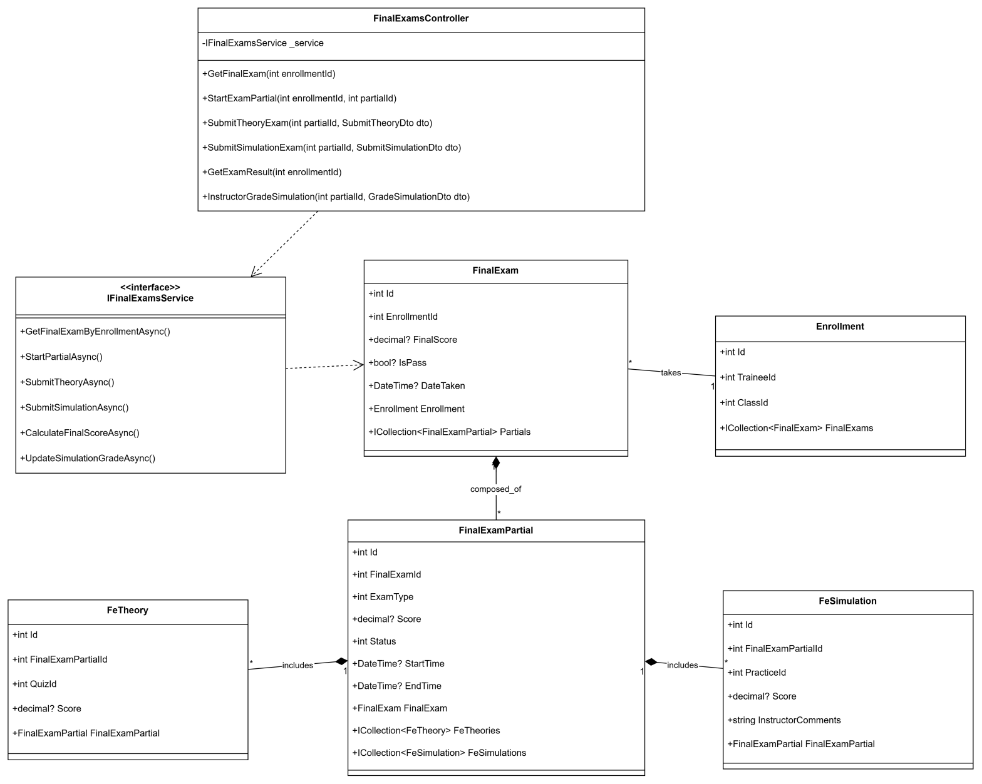

3.4.2 Sequence Diagram - Instructor Configs Final Exam
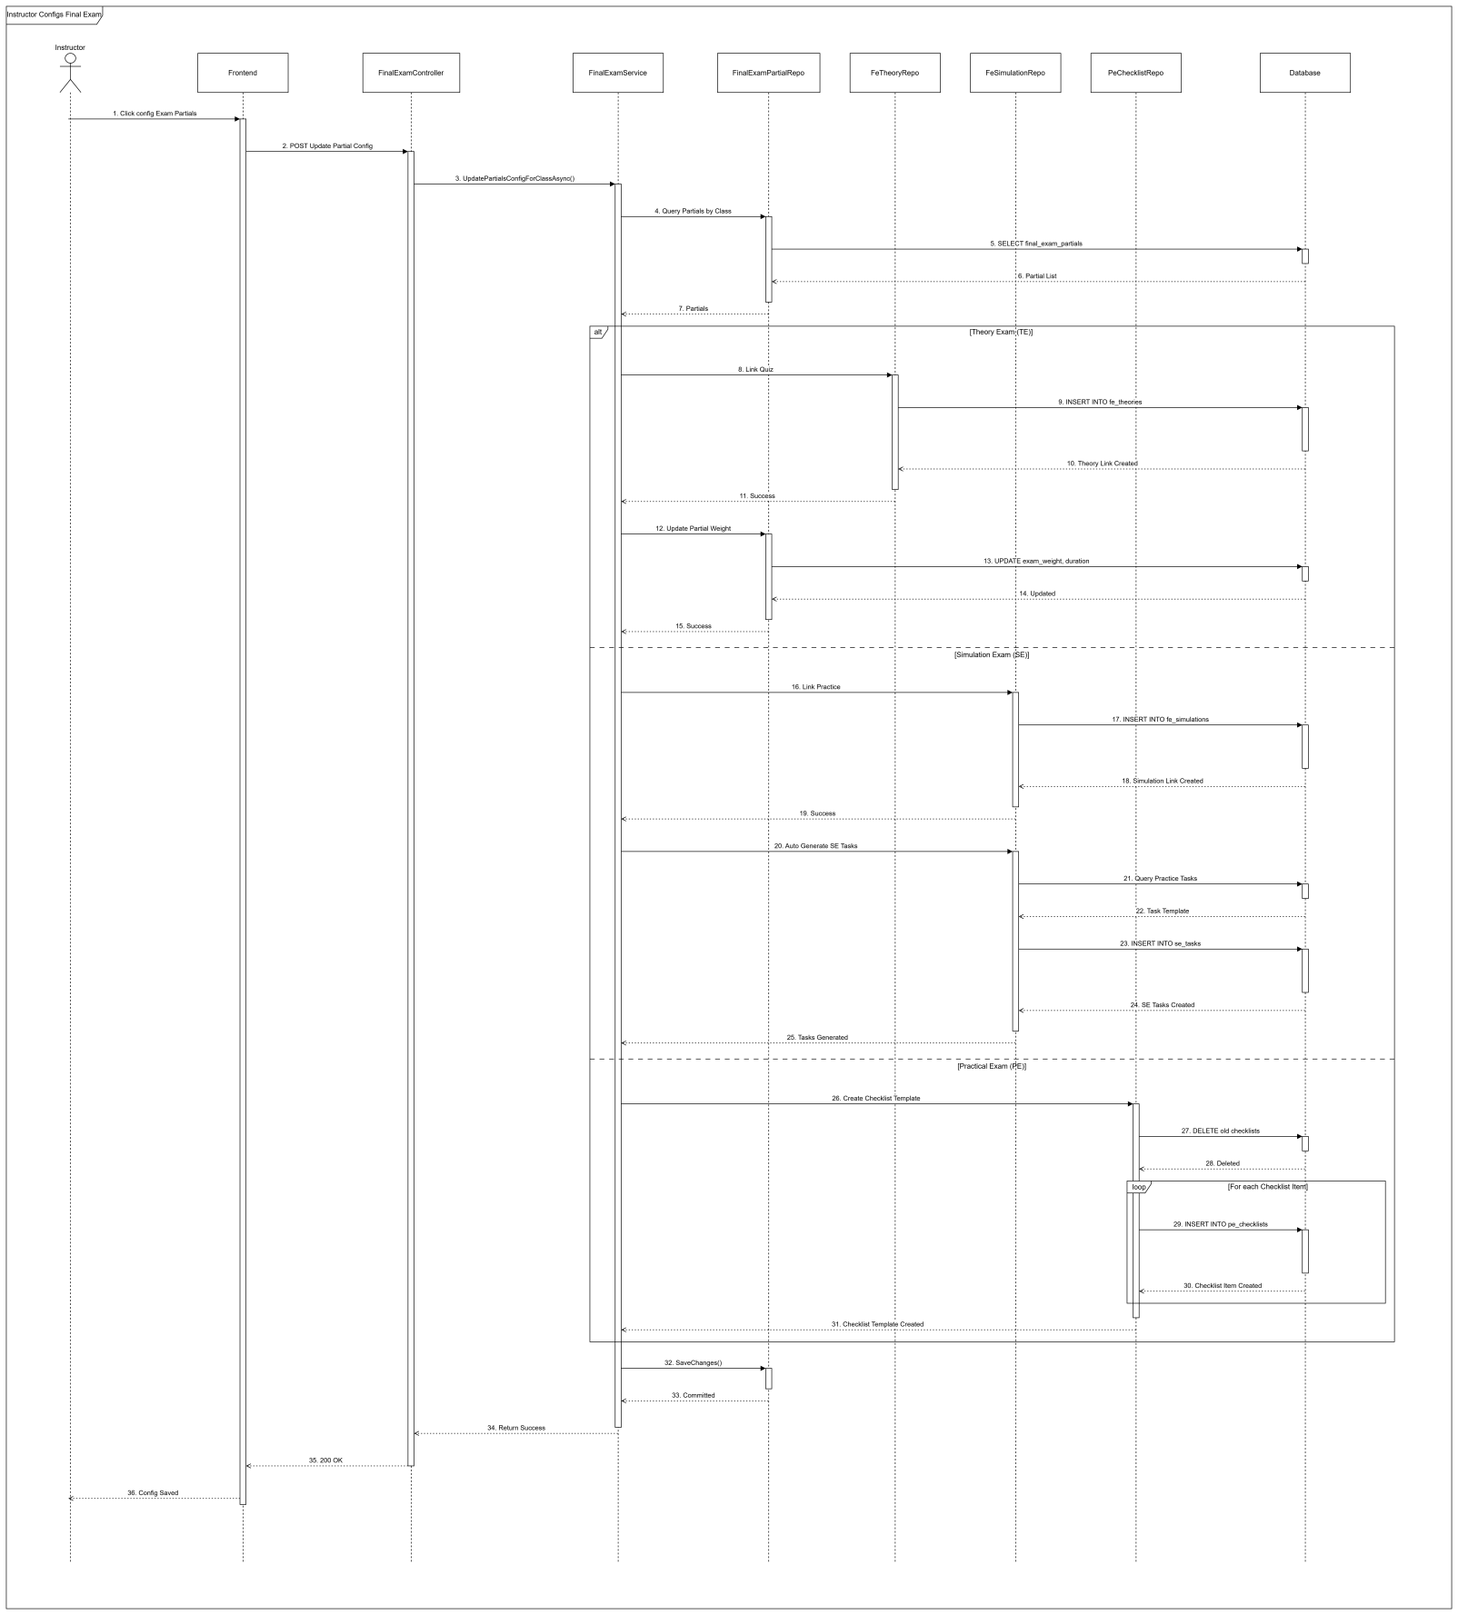

3.5 Dashboard & Reports

3.5.1 Class Diagram
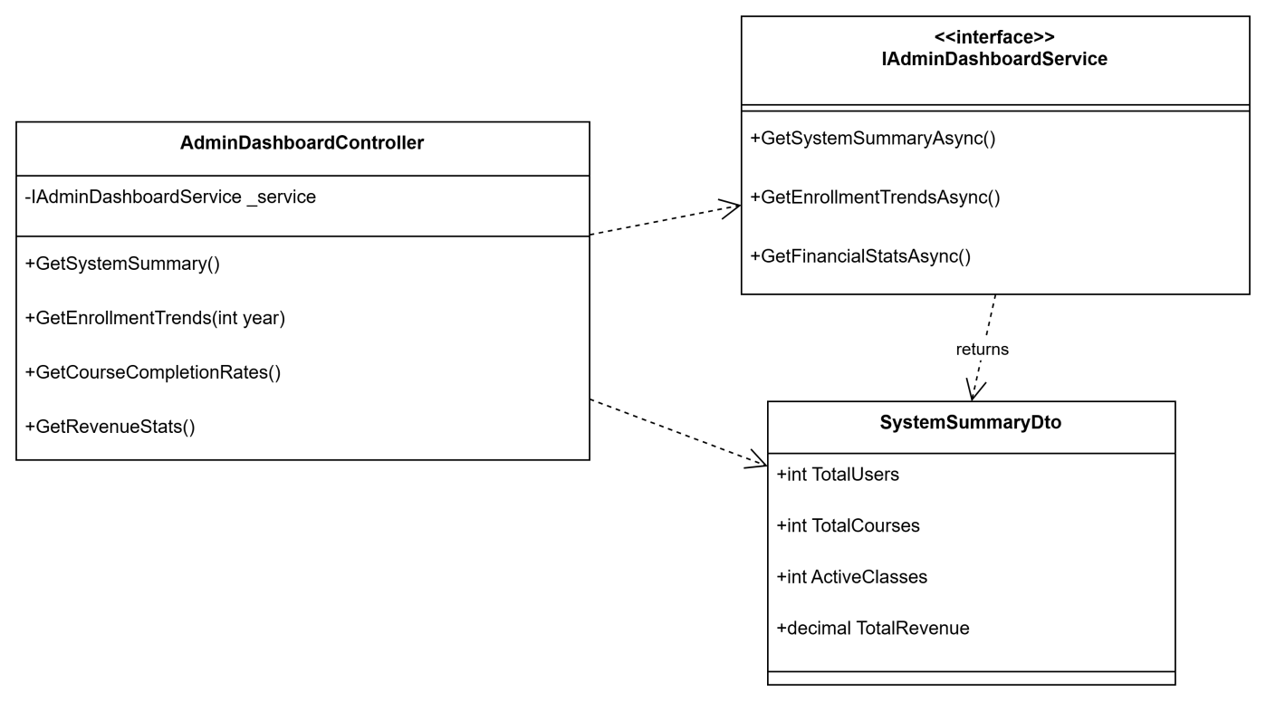

3.5.2 Sequence Diagram - Admin Views Dashboard
